Cyril Monti
Clément Tailleur
Rémi Ferreira

Project
Specifications

Table des matières
1. Introduction: 5
2. Project Specifications: 6
2.1. RESEARCH: 8
LINKYD-RSH-001: 8
LINKYD-RSH-002: 8
LINKYD-RSH-003: 8
LINKYD-RSH-003: 8
2.2. LINKY SIMULATION – DATA GENERATOR: 8
LINKYD-SIM-001: 8
LINKYD-SIM-002: 8
LINKYD-SIM-003: 8
LINKYD-SIM-004: 8
2.3. DATA ENGENEERING 8
LINKYD-DNG-001: 8
LINKYD-DNG-002: 8
LINKYD-DNG-003: 8
LINKYD-DNG-004: 8
LINKYD-DNG-005: 9
LINKYD-DNG-006: 9
LINKYD-DNG-007: 9
2.4. DATA VISUALIZATION: 9
LINKYD-DVZ-001: 9
LINKYD-DVZ-002: 9
LINKYD-DVZ-003: 9
1. GANTT 10
Use Case Diagram 11
1. Diagram 11
2. Generate Usage Hours 12
2.1. Objective 12
2.2. Actors 12
2.3. Data exchanged 12
2.4. Description of the sequence 12
2.5. Pre-condition 12
3. Generate Monthly usage 13
3.1. Objective 13
3.2. Actors 13
3.3. Data exchanged 13
3.4. Description of the sequence 13
3.5. Pre-condition 13
4. Generate devices specifications for each home 13
4.1. Objective 13
4.2. Actors 13
4.3. Data exchanged 13
4.4. Description of the sequence 13
4.5. Pre-condition 13
5. Generate Home total consumption profile 14
5.1. Objective 14
5.2. Actors 14
5.3. Data exchanged 14
5.4. Description of the sequence 14
5.5. Pre-condition 14
6. Simulate home consumption 14
6.1. Objective 14
6.2. Actors 14
6.3. Description of the sequence 14
6.4. Pre-condition 14
7. Build Frame 15
7.1. Objective 15
7.2. Actors 15
7.3. Data exchanged 15
7.4. Description of the sequence 15
7.5. Pre-condition 15
8. Write Frame in txt file 15
8.1. Objective 15
8.2. Actors 15
8.3. Data exchanged 15
8.4. Description of the sequence 15
8.5. Pre-condition 15
9. Decode Frame in proper format 16
9.1. Objective 16
9.2. Actors 16
9.3. Data exchanged 16
9.4. Description of the sequence 16
9.5. Pre-condition 16
10. Store data 16
10.1. Objective 16
10.2. Actors 16
10.3. Data exchanged 16
10.4. Description of the sequence 16
10.5. Pre-condition 16
11. Load data into database 17
11.1. Objective 17
11.2. Actors 17
11.3. Data exchanged 17
11.4. Description of the sequence 17
11.5. Pre-condition 17
12. Plot consumption of houses 17
12.1. Objective 17
12.2. Actors 17
12.3. Data exchanged 17
12.4. Description of the sequence 17
12.5. Pre-condition 17
Activity Diagram 18
1. Generate home profile 18
1.1. Diagram 18
1.2. Explanations 19
2. Electricity meter simulation 20
2.1. Diagram 20
2.2. Explanations 21
Class Diagram 22
1. Diagram 22
2. Home class 23
2.1. Attributes 23
2.2. Methods 23
3. Device class 24
3.1. Attributes 24
3.2. Methods 24
State diagrams 25
1. Home 25
1.1. Diagram 25
1.2. Explanation 25
2. Device 26
2.1. Diagram 26
2.2. Explanations 26

Introduction:
Our project is in collaboration with Hewlett Packard Enterprise and the goal is to do a POC (proof of concept) on the smart electricity meter theme. We will have to simulate the functioning of a smart electricity meter, put those generated data on a big data system powered by HPE, Vertica. Finally we will have to visualize this data to be able to see the energy consuming model in French homes.
The system can be divided in three main part, a data generator part, a frame management part and a data vizualisation part. Basically we want to generate data to fill a database, our goal is to simulate 120 Linky electricity meters over 1 year, which will send a frame that will contain the house electricity consumption every second. Once the database is full of data, we want to plot the evolution of energy consumption of houses over a period that we can modulate, to identify maybe later which device has been turned on, and when for example, and much more information about household consumption.
The data generator will have to simulate a home consumption profile, for this we will simulate the consumption of each device that a home can contain, and simulate what a home contain, depending on the home size or the number of persons in the family for example. A complicated part is the fact that a lot of parameters have an influence on others. For example in a family of 2 adults and 2 children the energy consumption is not the same as in a family of 1 adult. The devices will not be turned on at the same hours in those two families as they may have not the same lifestyle.
The frame management part is the part where we build the frame that will be sent to database, the frame as to be in the same format as the one used by EDF because we want our system to be usable with real EDF’s data. The frame will be sent to database after being decoded, and in order to do that a Big Data architecture has to be build.
The last part is the data vizualisation part, we will try to vizualise total consumption graph of a home.
The technologies that we are going to use, are Python for the data generator. In order to build the cluster, we are going to use Kafka to load our data into database, Vertica will be our database system deployed on 3 nodes made with RedHat virtual machines. For the data vizualisation we decided to use Tableau Software as it is becoming more and more common in companies, it is an important tool to master.

Project Specifications:
Let’s see which are the project specification that our project finally fullfil.
Project Spécifications
Name | Category | ID
Find the domestic appliances that use the most energy | RESEARCH | LINKYD-RSH-001
Find the energy consumption of the selected devices | RESEARCH | LINKYD-RSH-002
Get a model of the different home energy consumption | RESEARCH | LINKYD-RSH-003
Find samples of some data collected by Linky | RESEARCH | LINKYD-RSH-004
Generate data by simulating Linky's data collection with statistical model (Gaussian) for every domestic appliance | SIMULATION OF LINKY - DATA GENERATOR | LINKYD-SIM-001
Generate data following the different home usages | SIMULATION OF LINKY - DATA GENERATOR | LINKYD-SIM-002
Generate data knowing time (hours, days) and the domestic appliance usages depending on time | SIMULATION OF LINKY - DATA GENERATOR | LINKYD-SIM-003
Get an example of the frame send by linky to EDF database | DATA ENGENEERING | LINKYD-DNG-001
Design a Big Data Architecture | DATA ENGENEERING | LINKYD-DNG-002
Project Specifications(2)
Name | Category | ID
Create 3 Nodes with 3 VMs and install Vertica | DATA ENGENEERING | LINKYD-DNG-003
Install and configure Kafka | DATA ENGENEERING | LINKYD-DNG-004
Generate data with generation script | DATA ENGENEERING | LINKYD-DNG-005
Send data simulated in Vertica database system with Kafka | DATA ENGENEERING | LINKYD-DNG-006
Put frame into exploitable format | DATA ENGENEERING | LINKYD-DNG-007
Link data viz part with Vertica Database | DATA VIZUALISATION | LINKYD-DVZ-001
Create VM and install Tableau | DATA VIZUALISATION | LINKYD-DVZ-002
Vizualise data according to different parameters | DATA VIZUALISATION | LINKYD-DVZ-003

RESEARCH:

LINKYD-RSH-001:
The domestic appliances that use the most energy shall be found and selected to be added in our simulation.

LINKYD-RSH-002:
For the selected devices we shall find the energy consumption of each one.

LINKYD-RSH-003:
A model of the different home energy consumption behavior shall be found.

LINKYD-RSH-003:
Samples of some data collected by Linky should be found to build a better simulation that would be more accurate.

LINKY SIMULATION – DATA GENERATOR:

LINKYD-SIM-001:
The simulator shall generate data by simulating Linky’s data collection with a statistical model (Gaussian) for every domestic appliance.

LINKYD-SIM-002:
The simulator should as a parameter the different family and home behaviors to generate data.

LINKYD-SIM-003:
A timer has to be added in the simulator, and it shall generate data depending on the appliances usage that will be different for each hour.

LINKYD-SIM-004:
The simulator may also contain a User Interface in which the user should “customize” the data that will be generated.

DATA ENGENEERING

LINKYD-DNG-001:
To build the link between the data generator and the analytic part, we should get an example of the frames send by Linky to the EDF database to create our own frame.

LINKYD-DNG-002:
To be able to exploit our data and to visualize them we have to design a big data architecture.

LINKYD-DNG-003:
Our architecture will be composed of a Vertica database, distributed in 3 clusters. In order to do this we will have to create 3 nodes and install Vertica on them with 3 virtual machines. All the nodes will also have to be connected together.

LINKYD-DNG-004:
To load our data into the database, we will use Kafka, so it will have to be install on a server and be configured to work properly.

LINKYD-DNG-005:
Once the data generation script is over, we will have to launch it on the servers. It will generate a txt file with the consumption of the houses over time, every second.

LINKYD-DNG-006:
Once the txt file is generated, using Kafka we will load them into the Vertica database.

LINKYD-DNG-007:
As the frame send by Linky contains a lot of information in only one String, we will have to split it in order to put correct information into correct columns.

DATA VISUALIZATION:

LINKYD-DVZ-001:
In order to be able to use data vizualisation we will have to link it with our Vertica database.

LINKYD-DVZ-002:
The solution we choose for vizualisation is Tableau software, it works only under Windows so we will have to create and configure a Windows 10 virtual machine and install tableau on it.

LINKYD-DVZ-003:
The last step is to vizualise what we want, consumption of houses plotting with Tableau Software.

Use Case Diagram

Diagram
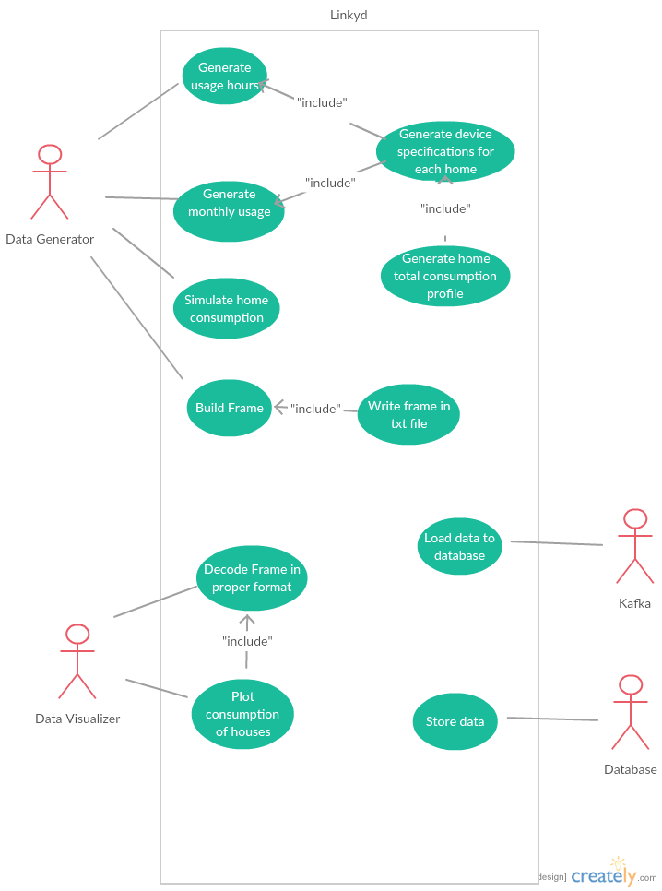

Generate Usage Hours
This correspond to the task n°LINKYD-SIM-004

Objective
The objective is to generate data usage by hours for each devices of the home

Actors
The data generator is concerned by this usage

Data exchanged

Description of the sequence
The generator will create data usage by hours for each device. Based on the home’s characteristics (number of people etc.). This will basically generate an array filled by Booleans. For example for a toaster there will be ones between 7 a.m. and 10 a.m. and zeroes after, because there is chances that this device will be used between those hours and not outside.

Pre-condition
To generate this, a home must be created, containing all its devices.

Generate Monthly usage
This correspond to the task n°LINKYD-SIM-004

Objective
The objective is to simulate the monthly usage for each device of the home

Actors
The data generator is concerned by this usage.

Data exchanged

Description of the sequence
The generator will create monthly usage data. Just like for the usage hours it will create an array full of Booleans, for example radiators will have ones between November and April, and zeroes between May and October, as they are used in cold periods.

Pre-condition
To generate this, a home must be created, containing all its devices.

Generate devices specifications for each home
This correspond to the task n°LINKYD-SIM-002

Objective
The objective is to generate specification for each device of a home

Actors
The data generator is concerned by this usage

Data exchanged

Description of the sequence
With the data that we generate before, we will be able to generate a profile of each device in a home. By multiplying usage hours profile with monthly usage profile and the consumption profile, we will be able to say if at a given time, the device could be running or not.

Pre-condition
The pre-condition is that the data usage hours and monthly has to be generated before

Generate Home total consumption profile
This correspond to the task n°LINKYD-SIM-004

Objective
The objective is to generate the total consumption profile of a house.

Actors
The data generator is concerned by this usage

Data exchanged

Description of the sequence
We will be able to generate the total home’s consumption profile with the data that we generated before by simply adding the consumption profile of each devices that this home contains. We will be able to get at each second the total consumption of a home.

Pre-condition
We need to generate each devices specification for the current home to be able to add them.

Simulate home consumption
This correspond to the task n°LINKYD-SIM-001

Objective
The objective is to generate home consumption data according to the Home profile.

Actors
The actors concerned by this usage is the data generator.

Description of the sequence
Following the home profile the data generator will simulate the consumption of a home and store data in the database. The simulation will depend on all the parameters expressed above.

Pre-condition
The home profile has to be built first.

Build Frame
This correspond to the task n°LINKYD-DNG-001

Objective
The objective is to build a frame with our generated home consumption data and send it to database.

Actors
The actor involved to build the frame is the data generator.

Data exchanged
The data we generated for the total home’s consumption profile.

Description of the sequence
The system should encode a frame that contains the data that we generated in order to send the data to our database. We should encode the frame in the same format that EDF do for Linky’s frames, so it will contain much more information than necessary, but it is a condition if we want our system to be adaptable with real EDF’s data. To fit with Linky’s behavior we will sent a frame each simulated second (not real time seconds, the system will generate data for one year faster than one real year…).

Pre-condition
We need the home total consumption that we generated.

Write Frame in txt file
This correspond to the task of data Simulation.

Objective
The objective is to write all the generated data into an Output.txt file.

Actors
The data simulation is concerned by this usage.

Data exchanged
Data generated about homes consumption.

Description of the sequence
For every generated second of every house over one year, a frame will be written in the text file containing the date and consumption at this moment.

Pre-condition
The data generator has to be running.

Decode Frame in proper format
This correspond to the task n°LINKYD-DNG-007

Objective
The objective is to receive and decode the frame with the data.

Actors
The database is concerned by this usage

Data exchanged
The data we generated for the total home’s consumption profile

Description of the sequence
The system should decode the frame received. As the frame generated looks like DATECONSUMPTION, we have to split it in order to put this two information in two columns.

Pre-condition
The frame has to be encode and send correctly.

Store data
This involves the tasks n° LINKYD-DNG-003 and LINKYD-DNG-006

Objective
The objective is to store the data that we generated

Actors
The database is concerned by this usage

Data exchanged
The data we generated for the total home’s consumption profile

Description of the sequence
This system must store our data decoded in order to allow us to analyze them. The data should be in the correct format to be able to analyze it.

Pre-condition

Load data into database
This correspond to the task n°LINKYD-DNG-006

Objective
The objective is to load the generated text file into the Vertica database using Kafka.

Actors
Kafka is concerned by this usage

Data exchanged
The data exchanged are what is inside the generated text file.

Description of the sequence
It will be much more detailed later. But basically Kafka will read as input the text file, build a queue containing all the messages and write them into our distributed database, under Vertica system.

Pre-condition
Have already a generated text file containing all the frames.

Plot consumption of houses
This correspond to the task n°LINKYD-DVZ-001, LINKYD-DVZ-002, LINKYD-DVZ-003

Objective
The objective is using Tableau software to plot some consumption graphs.

Actors
The Data Visualizer is concerned by this usage.

Data exchanged
The data exchanged are the views that we create from the Vertica database containing the informations we want to plot.

Description of the sequence
We will use DBeaver to create a table or a view with the data we want to plot (it is unnecessary to check 1 year of data if we just want to plot one month for example) and give this as an entry to Tableau in order to plot the graphs we want.

Pre-condition
Some views or table have to be created.

Activity Diagram

Generate home profile

Diagram
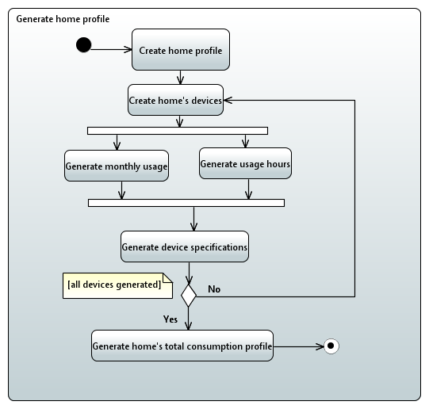

Explanations
This activity diagram correspond to the generation of the home profile use case and will describe how actions are supposed to follow, as each action as already been described in the previous part, we will not describe them as much as in the use case part. This correspond to the tasks n°LINKYD-SIM-002 and LINKYD-SIM-003.

Generating home:
We first need to create a home by generating all the variables of a home like the number of people in the house, or the number of TVs for example. All this numbers will be created following a Gaussian random function.

Generate device
A home contains many devices that consume electricity, we need to generate all the devices of a home and the variables linked to each device.

Generate monthly usage / Generate usage hours
In the same time we will generate the monthly usage and usage hours of each device. This two arrays populated with Booleans will be different for each device as you don’t use your dryer and your microwave the same way.

Generate device specifications
After all types of usages defined for a device, we can create this device with all its parameters.

Test all devices generated
If all devices of a home are generated then we can go to next step, generating home’s total consumption profile, otherwise we just repeat the process for creating a new device.

Generate home’s total consumption profile
After generating all devices we can generate the home’s consumption profile by adding all the devices together to build a home.

Electricity meter simulation

Diagram
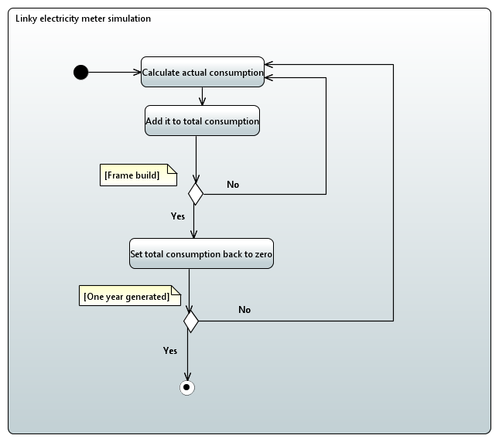

Explanations
This Activity diagram correspond to the Linky electricity meter simulation, the data generator will simulate the behavior of the created electricity meter thanks to the home profile. This correspond to the task n°LINKYD-SIM-001.

Calculate consumption
At each instant the system will calculate the actual consumption of each home, by simply adding the consumption of all the devices that a home owns.

Add it to total consumption
The actual consumption will we added into the total consumption of the house, to be able to send it in a frame to the database each second.

Frame build
We test if a frame was build, if not we add another time the actual consumption to the total consumption.

Set total consumption back to zero
If a frame has been built then we set back the total consumption to zero. To be able to put it back to another frame next second.

One year generated
We test if one year of data has been generated, if yes the system will stop generating data, if not it will continue.

Class Diagram

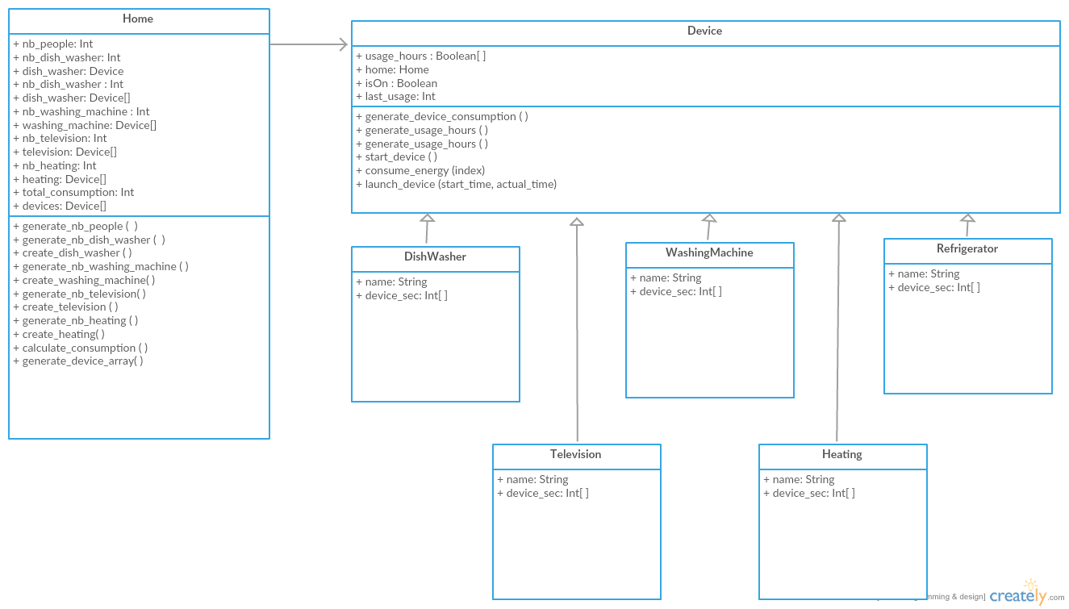
Diagram

Home class
The Home class is the one that will contain all the characteristics of a home.

Attributes
In this class the variables are:
- nb_people: an integer that will contain the number of people in the house, it will be generated randomly at the creation of a home.
- Variables like “nb_deviceX”: an integer that will specify the number of a same type of device in the house, like nb_TV could be from 0 to 5 depending on the characteristics of the house.
- Variables like “deviceX”: an array of integer that will contain as many of deviceX defined in the nb_deviceX variable. It will contain the created devices of each home.
- total_consumption: an int that contain the sum of all the devices consumption, in order to have the total consumption of the house.
- Devices: an array that contains all the different devices of a home. It will be coursed by the program for each second to see if the device is on and how much it consumes at the proper second.

Methods
- generate_nb_people( ): this method will generate the number of people that live in the house, this depend on the repartition of the population in houses in France, there is more chances to have a house with 4 people than with 2.
- Generate_nb_deviceX( ): those methods will generate the number of each devices depending on the distribution of those devices in France, for example only about 80% will have a dish washer.
- Create_deviceX( ): those methods will create a device according to the number of people in house and other parameters.
- Calculate_consumption( ): this method will calculate the consumption of a home, it will be launched each second in order to build the frame.
- Generate_device_array( ): this method will generate an array containing all the devices of a home.

Device class
This class is an abstract class that contains all the variables and method that are common to all devices that will inherit from this class. All the devices will inherit from this class and have all the same attributes and method, but the methods will be defined for each device class.

Attributes
In this class the variables are:
- usage_hours, an array containing Booleans. For each device, we create this array depending on the Home parameters and the device. For example for a family with 2 children the microwave will have chance to be used sooner than for a working man living on his own. A 1 means that for this hour, the device could possibly be used, a 0 means that the device could not be used (for example it is absurd or very rare to use a microwave at 4 a.m.)
- home, it contains the Home that the device is from. It is an instance of the Home class.
- isOn, a Boolean, it’s true if the device is on et false if it’s not.
- last_usage, a variable that will contain the date (in second) of the last time the device has been launched.

Methods
All the methods are abstract methods that will be override in the different devices class
- Generate_device_consumption( ): This method will generate an array containing the consumption of each second of a device.
- Generate_usage_hours( ): This method will generate an array containing Booleans for each hours depending if the device could be launched at the proper hour or not.
- Start_device( ): This method will start the device, by changing isOn to True.
- Consume_energy( ): This method will seek in the device_consumption array, at the current index and see if the device is consuming energy at this moment.
- Launch_device( ): This method will start a device and tell it to consume energy.

DeviceX classes:
All the devices inherits from the abstract class Device and all it’s methods and attributes. All those methods will be overrided in each device class.

Attributes
- Name, this String contains the name of each Device.
- Device_sec, this is an array of Int that will contain the consumption of the device for each second.

State diagrams
The class concerned by the states diagrams are the main class of our system, Home and Devices

Home

Diagram
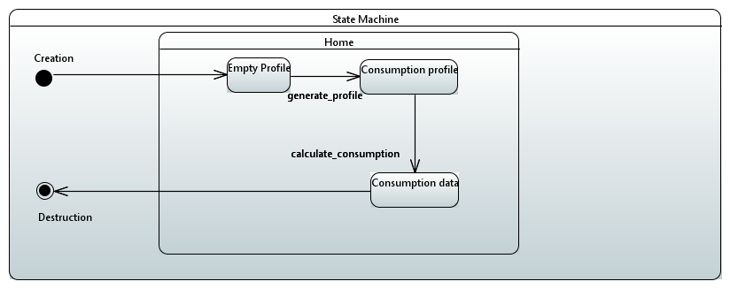

Explanation
When a home is created it is first an Empty profile, then thanks to the generate_profile method it will build a consumption profile that will be used to generate consumption data thanks to a dedicated method.

Device

Diagram
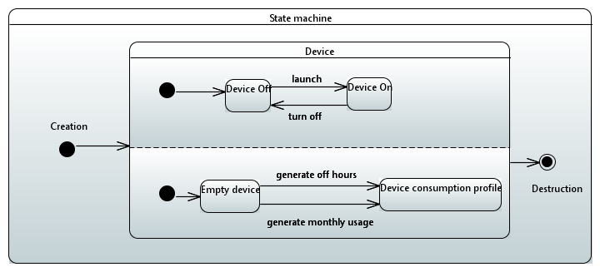

Explanations
The device can be turned on and off thanks to appropriate method, this will alternate its state between Device on and Device Off. When generated the device is empty, thanks to 2 functions explained before, generate off hours and generate monthly usage it will fill up the device consumption profile and it will be used in the Home class to calculate consumption.

Now that we have seen a global view of our project, let’s go deeper into each part of it. Our project can be divided into 3 parts, the data generation, the data engineering and the data visualization. As we have gone already a lot into Data Generation, we will not dive into it as much as the other parts in the following explanations.
- Data Generation
I.A. Research
For the data generation a research has been made about the consumption of households in France, the consumption of the devices, and the distribution of the people in homes in France.
- The distribution of peoples in French houses.
In order to have a script that will generate data as close to the reality as possible we had to find the distribution of people in French homes. With this we will generate homes in our script with the same repartition of people in it as it is in the reality.
[Insérer graph de la repartition de la population dans les foyers]
- The distribution of each devices in France.
With the same challenge: fit as much as possible to the reality we also had to find how many percent of French houses contains each device. For example not all the houses may have a television.
[Insérer graph des devices]
Our script take care of all those parameters.
- The consumption of each device.
Each device has a curve of consumption in Watts over time. Another challenge was to find those curves for each devices. It was really hard to find them, but we succeeded for the dish-washer, the refrigerator and the washing machine.
[Insérer les graphs]
But for the other devices that we implemented into our code we had to use our common sense. In fact devices could be classified into some categories. Like you can see on the array below:
Run all day | Cyclic | Run for each use different period | Periodic Use
Refrigerator | Washing machine,  Dish-washer | Television | Heater

Some devices like the Refrigerator run all day, so they are pretty simple to implement into our code, we can easily generate a curve of consumption over time for 1 day and each second and repeat it each day.
Some other device are cyclic, which means when you launch them, they do their cycle and then, they turn off. This kind of device is also easy to implement as you just have to create a array containing the consumption for each second during a cycle, and when the device is on it stays on and consume energy during this full cycle.
One other kind of devices are the devices that have a different usage time, each time you start them. Those devices are the most complicated to implement into our script. For example when you start your Television, you will not always do it for half an hour and them turn it off. Each time you use it, it is for a different period. What we did in our script is to generate a random number (based on a Gaussian distribution) of how much time you will use your Television when you start it. And we repeat the Television signal until this generated period of time is over.
Finally we have a last kind of device like the Heater which you launch only at some period of the day and some period of the year. This device was pretty simple to implement but we did not find a signal for heaters. So we decided to build it.

